Bill Stefanus tanujaya

Taman Surya 5, Kalideres,  West Jakarta, Indonesia  Phone: (+62) 822 9890 9638  Email: billstefanus928@gmail.com  Website: billstefanus.com | 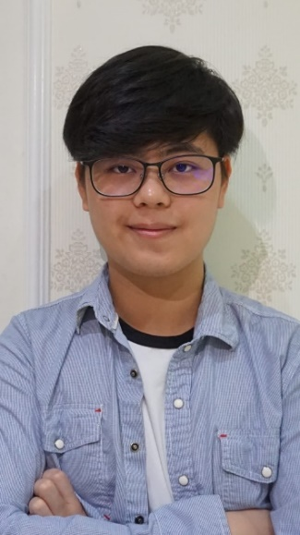

Profile

I graduate from Asia Pacific University with bachelor’s degree for Information Technology with specialism in Mobile Technology in 2019 and currently looking for a full-time job in the field of mobile application. I have a lot of contribution and experience from my previous work in Mobile App Development especially Android, which makes me the perfect candidate to be working in your company. other than Mobile App, I also can effectively work as Front-end Web Development, I have an experience on using several JavaScript frameworks.

Skills

- Language Skill
(Scale: 0 = Poor, 10 = Excellent)
Language | Spoken | Written
English | 10 | 8
Bahasa Melayu | 8 | 8
Bahasa Indonesia | 10 | 10

- Technical Skill
(Scale: 0 = Poor, 10 = Excellent)
Skill | Scale
Java | 9
JavaScript | 7
Swift | 5
React | 6
NodeJS | 6
ExpressJS | 7
Google Firebase Firestore | 8
MongoDB | 8
HTML + CSS | 8
C# | 7
C++ | 8
Postman | 7
Retrofit 2 | 8
Phyton | 7
SQL | 6
Angular | 5

- General Skill
(Scale: 0 = Poor, 10 = Excellent)
Skill | Scale
Research | 8
Communication | 8
Analysis | 7
Decision Making | 8
Teamwork | 7
Organizational | 8
Leadership | 6
Microsoft Office | 8

Education

2016 – 2019 Asia Pacific University of Technology and Innovation, Malaysia

Studying for Bachelor of Information Technology (specialism in Mobile Technology) - Double Degree. Graduation expected on November 2019

2016-2019 Staffordshire University (Corporate University)

Studying for Bachelor of Information Technology (specialism in Mobile Technology) - Double Degree. Graduation expected on November 2019

Working experience

- IT Related
- SevenGorilla (Mobile Application Developer)
- Central of Technology and Innovation (R&D Team)

- Others
- PT. AQUAS (Technical Assistant)
- CV.Tirta Makmur Abadi (Cashier)

Projects Contribution

FinLit 2020
- FinLit is an application with the objective to help its user to manage their financial better and also help them make a budget planning to pay their debt if the user has any debts

Mitsubishi CRE Connect 2020
- CRE Connect is an application that is targeted for the staff to make all the car service booking for his/her Mitsubishi branch to be more manageable.

W Element 2020
- W Element is targeted to China market, it is an application that can help its registered merchant and users to get a recommendation of a nail art that may suit them, and also it can help users to look for the nearby store to do their nail.

Creme 2018-Today
- Android Mobile Application that can help people see review of
Restaurants and do reservations in a restaurant. All reservations will
be handled by restaurant owners that are registered in the cloud database. Creme is now can be downloaded in Google Play Store in several countries.

QR App 2020
QR App is an application that can be used to help its user to generate both QR Code and Barcode and Customize it for their needs, it also can Scan Barcode and QR Code and redirects them to other app based on what data the scan reads. it also has a history feature that can help user see their previous scans

Optio 2017
- IOS Mobile Application that can help simplify daily task of people that
Travel a lot by providing several features such as currency converter, calculator, chatting, and task reminder all in one application.

TravelSystem 2019
- A Full-Stack Web Application using MERN Stack with Redux and Axios help
Connect Front-End and Back-End, it is a simple web application that can help its user to find and book a travel package that are registered by the travel agents.

iConsult (APSpace Mobile Application) 2018
- Contributes in iConsult development during internship period in Center of Technology & Innovation (CTI), teaming up with other senior developers that are very passionate in their work and always strive to improve their skills. It has been an honor for me to be working with the R&D team. iConsult is a feature inside APSpace created using Ionic and Flask that can help APU student to book a consultation hour with a lecturer.

Honors and Awards

Microsoft Virtual Academy 2016-2017
- Database Fundamentals
- C# for Absolute Beginner
- Creative Coding Academy

Project Management Institute 2017
- Deadline Management

EDX 2017
- Microsoft: DEV276x Learn to Program in Java

Udemy 2017
- Complete Java Masterclass
- Java Swing (GUI) Programming from Beginner to Expert

Organizational Experience

2018 Asia Pacific University of Technology and Innovation, Malaysia

Fresh Summer Committee

2017 Project Management Institute

Volunteer

Interest

- Gaming
- Swimming
- Badminton
- Travel
- Photography

References

Available Upon Request

